Welcome to Our Savior’s Preschool!
We hope OSLC preschool will meet your child's needs. OSLCP believes a quality preschool is a partnership between parents, preschool, local public schools, our community and the congregation. We are so blessed to have families take an important part in our preschool community.
Our care and concern for nurturing the whole child spiritually, physically and emotionally is important to us and we want to extend this to your family. OSLC considers our preschool families ‘Campus Members’. Please let us know if OSLC can be of any assistance in meeting your family's needs.
The staff at OSLCP is looking forward to a new school year with high expectations and blessings for all families.

Debbie Cooper OSLC Preschool Director

Everyone is Welcome at OSLC!
Preschool Families are always welcome to join us for worship on Sunday mornings.
Worship Service (Blended music) at 9:00am
New! Learning time during the 9:00am service for preschoolers through 5th grade.
Learning for Everyone - 10:00am
Worship Service (Chamber Choir) at 11:00am
Nursery care is provided for babes and toddlers.
Come and join others from our preschool community once a month at our Friends and Family Gathering.
Read flyer about FFG!
For more information: Go to www.oslc-everett.org

We Love Your Photos!
Photos of the children are used frequently during the year in discussion and bulletin boards, etc. Please bring a picture of your child to Open House. The picture will be returned at the end of the year but may be pinned or
stapled, so please don't send a 'treasured favorite'. Please keep pictures 4” x 6” or smaller, as we have many students at OSLCP!

Your Child’s Class List
We are sending home a class list for your child's class to help parents arrange carpools. Registration changes sometimes occur in the first month of school. Lists will be updated in October, if necessary.

Immunizations
Current immunizations are required of enrolled preschool children. Please include month and year of immunization (it does not need to be signed by your doctor.)
Please follow your pediatrician's recommendation as to which immunizations are needed for your child.
Nobody likes shots but they keep us healthy and well!

Check List for Open House
Please read and fill out all the requested information and needed items for preschool and give them to your child's teacher at Open House.
Please tell your teacher at open house if corrections need to be made on the class list or emergency information needs to be updated.
Items Needed for Open House
- Immunization form
- Emergency snack
- Child's picture for bulletin board. (4x6)

Please bring the following items to Open House. Thank You!
- 2-year-old families – 2 cans of shaving cream
- 3-year-old families – 1 package of handwipes
- 4-year-old families – 1 large pack of 5-ounce drinking cups (no plastic please.)
- Pre – K 2 families – 1 box of tissues
Preschool Tuition
The September 2019 and the June 2020 tuition are due on your child's first day of class for families that prefer to pay monthly by cash or check.
Families who are participating in Vanco’s Simply Giving pre-authorized automatic withdrawals will begin on September 1st or 15th.

Tuition checks can be dropped in the tuition slot in the upstairs preschool building by the director’s office. Please be sure to label the check with your child's name, class and teacher's name, to ensure proper credit. Please, do not put the check in an envelope, it clogs up the tuition holder.
Preschool tuition is pro-rated by the number of days your child attends preschool.
Tuition will be paid once a month, September 2019 through June 2020.
If you have any questions concerning your child’s preschool tuition, please contact the director at (425)252-0413, Ext.113

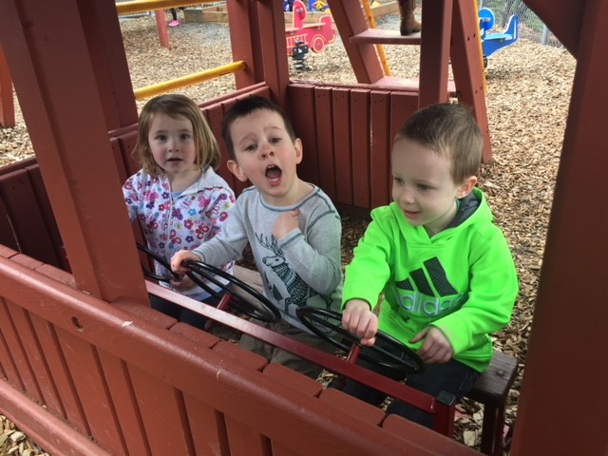
Fun in the ‘Slide’ playground

We Appreciate Volunteers!
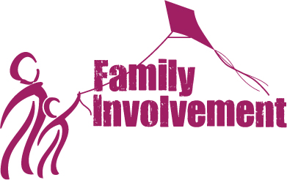

Volunteers make our preschool community stronger and safer. Volunteering is a wonderful opportunity for parents to form new friendships. Below are just a few things parents or other significant ‘grown-ups’ in our preschool community can do to make our school a great preschool!

- Join the Parent Event Committee by helping with special events for preschool.
- Volunteer to decorate your trunk at our annual Trunk or Treat Halloween Bash. Volunteers are also needed to set up during the day.
- Volunteer to be a barista!
- Photographer for special events
- Miscellaneous volunteers for a variety of tasks.
- Volunteer to mow and weed the grass in the Nature Park.
- Cook with preschoolers
- Read stories to preschoolers
- Handy ‘person’ for minor repairs.
- Help with annual fundraiser in Spring
- Ideas are endless!
- Help with our monthly Friends and Family Gatherings.

Interested in any of the above, come and see the director or email debbie@oslc-everett.org for more information.

