OUR SAVIOR’S LUTHERAN PRESCHOOL

**FEBRUARY 2020**

### *Save the Date!*

### Preschool Registration Dates

### For the 2020-2021 School Year

For Currently Enrolled Preschool Families.

**Wednesday March 4th**

**Time: 8:30am – 1:00pm**

Please note: You must be current on this year’s preschool tuition before registering for 2020-2021

**OSLC Members may register anytime beginning Sunday February 9th**

### Open Enrollment to Public!

*Spread the word to Everyone!*

**Thursday March 5th**

**Time: 9:00am – 1:00pm**

*Feel free to take extras registration forms to pass out to your friends, neighbors and family.*

The new 2020-2021 preschool registration forms for next fall will be available on the front desk in the Learning Center entryway, beginning Monday February 10th. The new registration forms can be downloaded from our website after that day.

**No registration forms will be accepted prior to March 4th** unless you’re a church member or currently on the OSLC Preschool committee.

**WE CARE ABOUT YOUR KIDS! Please drive slowly in parking lot.**

## Will you be my Valentine?

Class ‘valentine’ fun will include exchanging cards with classmates. Please send the correct number for your child’s class. Put your child’s name (who it’s from) on the back of the card.

**Please do not put the other student’s names** **on the envelopes**. Send the cards on the day requested by your child’s teacher. This is one of the first times many children have the experience of giving and receiving Valentines. It is exciting and a great incentive for your child to practice writing their name!

**Preschool Needs**

Newspaper! Please remove the advertisements. Thanks!

**Love, Trust and Forgiveness**

When Jesus says, “Let the little children come to me” he is speaking directly to us. He is asking adults to simply have a childlike faith and acceptance of his abundance love for each one of us. *Don’t sell yourself short, he values everyone!* Loving and forgiving goes hand in hand and that’s what God’s son Jesus did for us – accepting us with his never-ending and unconditional love.

Learning through play is so valuable for young children

**Ladies Night Out at OSLCP**

**Thursday February 6th**

**7:00pm to 9:00pm**

***Rock Out with Reverend Pam Gompf!***

Come and enjoy a fun evening of rock painting and hear Pam share her enthusiasm for art and nature.

I guarantee, you’ll have amazing and fun time and leave feeling refreshed and inspired to try to new things.

Enjoy tasty lattes, wine, door prizes and appetizers!

$10.00 suggested donation for supplies.

Invite a friend or two!

**Please read the other side to see what’s happening at OSLC Preschool this month!**

**Fat** **Tuesday Pancake Day**

**at OSLCP!**

Another name for Shrove Tuesday



**Tuesday February 25th**

**Time: 8:15am - 9:30am and 11:15am – 12:30pm**

Come before or stay after class and enjoy a pancake breakfast.

Siblings welcome!

**Donations only**

**This year proceeds will benefit Australia’s wildlife.**



*Firefighter shares his water with a dehydrated koala bear.*



***Special Family Chapel Day***

***on Ash Wednesday!***

**Wednesday February 26th**

**8:45am or 12:30pm**

Come and join your child at Family Chapel on Ash Wednesday.

Pastor David will share why we acknowledge Ash Wednesday. Why do some churches do strange things like rubbing ashes on people’s foreheads or hands? What does this mean? If possible, it would be wonderful if parents can come and join their children at Family Chapel.

A note will be sent home in a few weeks asking your permission to put an ash cross on your child’s forehead or hands, but we encourage parents to partake in this ritual at the same time with their child. Doing things together makes it more meaningful to both parent and child.

Another reminder note will be sent home to remind you about Ash Wednesday. This will be the shortest Ash Wednesday service you’ll ever attend but it will carry the same significance as a traditional Ash Wednesday for your child.

***Get ‘Ashed’ on Ash Wednesday!***

***Reminder!***

**Pre-K 2 Information Meeting**

**Wednesday January 22nd**

**11:00am and 12:30pm**

***Is Your Child Ready for Kindergarten?***

Many children with late spring or summer birthdays canbenefit from an extra year at preschool.

If they go into a full day kindergarten, it should depend on physical stamina, social abilities, and previous preschool experience and somewhat academics. For the borderline preschooler, the decision is usually based on “Do you want your child to be a leader or a follower when they are in kindergarten?”

**One year of maturing is so beneficial for young children entering the future school years.** Please keep in mind, it’snot holding a child back, it’s giving a child ‘a gift of time’ to mature into a confident and curious learner.

**If you have one little doubt in your mind about your child going into all-day kindergarten class,** please talk to your child’s current teacher and attend the Pre –K 2 information on Wednesday January 22nd in the Commons by the fireplace.

Its best if both parents can attend and hear the same information to help you decide what is best for your child.

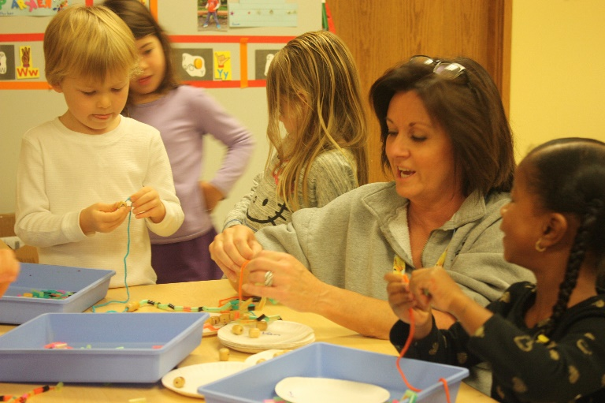

Ms. Nancy’s class working on their kindergarten ‘pincher’ skills

***Reminder!***

**Pre-K 2 Information Meeting**

**Wednesday January 22nd**

**11:00am and 12:30pm**

***Is Your Child Ready for Kindergarten?***

Many children with late spring or summer birthdays canbenefit from an extra year at preschool.

If they go into a full day kindergarten, it should depend on physical stamina, social abilities, and previous preschool experience and somewhat academics. For the borderline preschooler, the decision is usually based on “Do you want your child to be a leader or a follower when they are in kindergarten?”

**One year of maturing is so beneficial for young children entering the future school years.** Please keep in mind, it’snot holding a child back, it’s giving a child ‘a gift of time’ to mature into a confident and curious learner.

**If you have one little doubt in your mind about your child going into all-day kindergarten class,** please talk to your child’s current teacher and attend the Pre –K 2 information on Wednesday January 22nd in the Commons by the fireplace.

Its best if both parents can attend and hear the same information to help you decide what is best for your child.



Ms. Nancy’s class working on their kindergarten ‘pincher’ skills