2020-2021
Automatic Withdrawal Authorization Form
(Only one withdrawal authorization Form is needed per family)

Name of School: Our Savior’s Lutheran Church and Preschool
Effective Date: September 1, 2020 through June 1, 2021
Name of Parent: ____________________________________________________________________
Address: ___________________________________________________________________________
City: __________________________ State: _____________ Zip code: _________________________
Checking account w/void check Name on check: _____________________________________________
Checking account  Routing Number: ___ ___ ___ ___ ___ ___ ___ ___ ___  (Valid routing number must start with 0, 1, 2, or 3)  Account Number: _________________________________________  Withdrawal will be taken out on the 1st of month, September through June. | 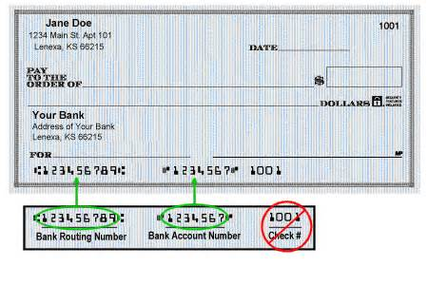
Agreement: I authorize the above school and Vanco Services, LLC to process debit entries to my account. I understand that this authority will remain in effect until I provide reasonable notification to terminate the authorization.
Authorized Signature_________________________________________ Date: _________________
(The Simply Giving Program endorsed by Thrivent Financial Bank

Please read and fill out the information below very carefully
 | Child’s Name | Child’s Class | Monthly Tuition | Other class child is enrolled | Other class Monthly Tuition | Monthly Donation to support OSLCP | Total Monthly Tuition
1
2
3
4

